

Game Design Document

Karl Pytte – bitRaid Games

# Executive Summary:

The Black Debt is an educational game designed for Year 11 Students that aims to teach Accounting and finance through games assisted learning. Players will control a pair of adventures in a strategy game that blends economics with medieval fantasy. The game will feature an intuitive design that is perfect for students, as well as feature a colorful aesthetic that helps bring the game world to life. Successful players will not only conquer the game system; they will also find themselves better prepared to take on life’s financial challenges.

A medieval strategy game designed to teach accounting and finance. Fight bandits, learn economics, save the world.

Contents

Executive Summary: 1

Key features: 3

Design Philosophy 4

Stakeholders: 4

Story 5

Core gameplay: 6

General Gameplay elements 6

Starting Screen 7

Overworld 7

Rules 7

Mechanics 9

Goals 10

Towns 11

Rules 11

Mechanics 11

Goals: 12

Game HUD 13

Combat: 13

Accounting Quests 13

Econonomicron 14

Tutorial Section: 15

Win & Loss States: 15

Example of Play: 16

Target Platform 16

Aesthetics 17

General Theme 18

Tutorial 18

HUD 19

Overworld Map 19

Town Hub 20

Asset List 20

Testing & Analytics: 21

Technical Considerations: 23

Hardware: 23

Software: 23

References: 24

# Key features:

* Accounting-based RPG system – The denizens of this world are in peril, and it is up to the player to save them with their knowledge of accounting and finance. As players learn more and achieve mastery over the basics, they will be able to take on even greater challenges.
* Comprehensive real-world economy - The world will feature a resource system in which goods never leave the economic cycle, with players able to observe the process from start to end.
* Intricate trade system – Goods aren’t always made where they are desired, and it is up to the player to ensure that goods flow where they are needed most, and where the most profit may be earned.
* Seamless microworld blending of education and games – A merchants Quest operates under the design philosophy that immersion learning is the most effective method to teach difficult topics. The result is a game where players are so focused on having fun, they don’t realize that they are learning.

# Design Philosophy

Having an understanding of economics and finance is a huge advantage in the business world, and sadly many individuals are reluctant to learn as it is a topic that has traditionally been seen as intimidating and brutally dry. Accounting Quest attempts to allow individuals a starting point with which to gain an understanding of the core systems and their practices, from which the player may then advance toward a state of complete mastery.

Furthermore, this game operates under the philosophy that current models of teaching are inefficient, not necessarily because of the content, but because individuals (especially children) are unable to engage in self-regulated learning. This game therefore attempts to take one of the more difficult to teach topics, and present it within an “endogenous fantasy” setting (Rieber, 1996). Due to this, players learn accounting first to satisfy the requirements of the game, and from there can learn its real-world applications. This differs from many educational games; as rather than build a shell of a game around the learning outcome, the outcome is treated as a mechanic that serves gameplay.

# Stakeholders:

Accounting Quest is designed to meet the needs of the School Curriculum and Standards Authority of the Government of Western Australia with regards to satisfying the key learning outcomes identified in the “Year 11 Accounting and Finance: General Course” syllabus (2016). These learning outcomes have to do with:

* Personal Finance.
* Accounting for small cash entities.

The key learning outcomes identified on pages 8-13 of the syllabus will be both taught and assessed within the game, through an interaction cycle whereby students will:

1. Encounter a quest that requires specific knowledge, with a hint as to where to find the knowledge.
2. Read the content in the “Econonomicron” that covers that specific topic.
3. Finish the quest by demonstrating an understanding of that content through a small assessment.

This interactive cycle will be the primary focus of the game, with the other features seeking to reinforce the games-assisted learning. The research done by Rieber (1996) claims that presenting content in an environment that is fun and exciting causes a notable increase in the retention of information among students. It is in light of this that the other game mechanics seek to give students the ideal environment in which to learn the course content.

# Story

The game features two main protagonists; a wandering merchant named Janet, and an accountant named Steven. Janet encounters Steven in an alleyway beset by thugs, and assists him in combat: this scene is entirely 2d and is a simple storyboard. Afterward the two introduce themselves: Janet is an initiate in the merchant’s guild; an investment faction that helps startup businesses by providing loans and advice. The downside being that Janet must make ever-increasing payments every month to recover the debt, or risk the seizing of her assets and the blacklisting of her name.

Steven is an acolyte within the “Order of the Red Letter”: a sect of wandering financial experts sworn to protect the innocent from the danger of confusing economic systems, as well as rooting out those who would bend the rules to their own end. Steven must prove himself by helping out all those who would ask for aid, and in doing so will rise in the ranks of the order.

After the intro story, players will always be playing under the assumption that they are controlling both characters as they wander the land in a newly-formed business partnership. Character portraits will appear for Janet whenever mercantile action scooch as trading goods are done, and Steven will appear when the player attempts accounting quests.

# Core gameplay:

These mechanics, rules and goals are at the core of the player experience, all other elements of the game serve to enhance these in some way.

## General Gameplay elements

These elements apply in all aspects of the game, and are always in effect.

* The game is designed primarily for the keyboard and mouse, and as a result will be navigated in light of this input method; no controller or touch-screen interface is planned at this point.
* The gamespace will be entirely discrete, with no continuous elements in any area or mechanic.
* The game is turn-based, and as a result no action outside of player control will take place in the game until the player has ended their turn, and the payer will not receive another turn until all necessary background actions have occurred.
* There is no “end turn” button; player turns will end when the player input is received.
* Critical game mechanics will not rely on outside knowledge, and will have some form of tutorial or learning resource within the game itself. The player will not be required to look up or use external resources to progress through the game.
* All aspects of game design will be appropriate for a Year 11 high-school audience, and will be tailored to maximize the engagement of this target audience.
* The story will be unbiased and will not contain any dialogue, flavor text, or options that could cause offense. Should any be identified during playtesting or otherwise, these will be changed immediately.
* The entire experience will aim for roughly 1 hour of in-game time before the victory condition is reached, and currently no save feature will be implemented.
* Coding will always use the method that is most efficient in terms of system resources, in order to keep the minimum system requirements as low as possible.
* The balancing of game mechanics will focus primarily on preventing the development of “First order optimal strategies”, to ensure no dominant playstyle is developed.
* The game will feature three core resources:
  + Gold – Earned Through trade, prevents loss condition
  + Integrity – Earned through questing, essential for win condition
  + Time – Spent when conducting player actions, brings loss condition closer.

## Starting Screen

When the player starts the game, they will be presented with a Screen which contains a splash art of the game, and have the ability to select a set of buttons on the UI with the mouse. The planned buttons are:

* 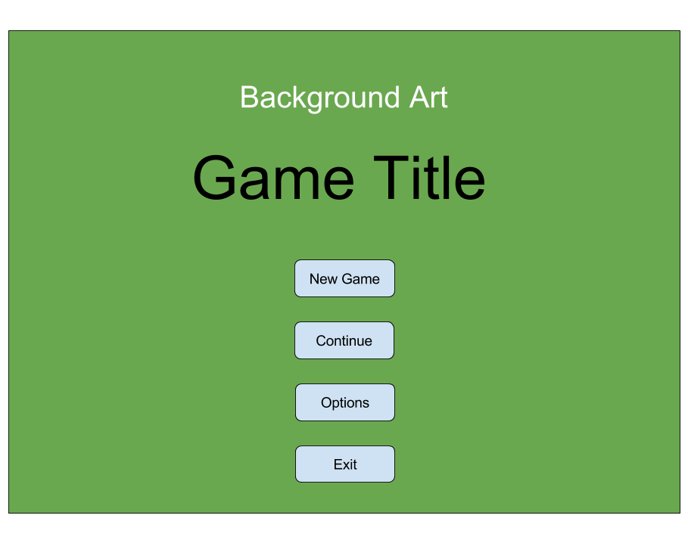New Game – Begins the game from the start, with no loaded data
* Tutorial – Allows the player to paly though an introductory section of the game.
* About – A short series of screens complete with the game mission statement, the credits, and acknowledgements to outsourced assets.
* Quit – ends the game if it’s a stand-alone version.

## Overworld

The majority of the player time will be spent navigating the Overworld, and will be concerned with maneuvering the player caravan from the starting town to the destination town based on the goods being transported.

### Rules

These are concerned with what the player can and cannot do, as well as the limitations of the gamespace.

* Players must maneuver across the map by using the mouse, selecting a tile adjacent to the one occupied by the player caravan.
* Movement is turn-based and players can only see the mechanical information for the surrounding hexes (hexes that share a border with the one occupied by the player caravan).
* Moving to a new tile counts as the player turn ending, and time will pass in correspondence with the amount of time that Hex consumes (currently 1 hour for each hex).
* The camera shows the gamespace from a birds-eye view overlooking a number of Hex tiles, the camera is fixed at a ¾ view angle and cannot rotate, however it can pan across the landscape.
* The gamespace is of a fixed size, and the player will not be able to traverse across the borders which will be occupied by some impassable object (mountains, desert, ocean, ect.). Likewise, the camera cannot pan across these borders.
* The town and road hexes are always the same type, but all other hexes are randomized.
* The player may move across all Hexes aside from the border, however each hex will have certain advantages and disadvantages.
* Sticking to the safe tiles (road) will minimize the risk to the player when travelling between towns, however venturing off the road (forest) will often save time and has a chance to reward treasure (applies instantly), which may be redeemed at the town for gold.
* Time is a resource which is consumed as the player moves to a new Hex, cycling between night and day.
* Each Hex has a risk of ambush to the player, with this risk doubled at night, encouraging players to only travel during the day.
* If the player is ambushed, a combat scenario will trigger *See combat section for details.
* Certain tiles have a risk of hazards. Should players proc this hazard, they will lose a number of goods based on the severity of the hazard (currently locked at one), and it is unavoidable.
* All goods/treasure that is lost/acquired will be automatically subtracted/added to the caravan, the caravan has limited space and thus anything found while the caravan is full will be lost.
* When time reaches night (6pm) players will have the option to continue travelling, or camp for the night. If players camp, time will automatically traverse forward to morning (6am).
* Towns will be surrounded by hexes from which raw resources will be gathered.
* Towns are closed at night between 6pm and 6am, and cannot be entered.
* Each town will have a number of villagers, which work every day (9am-5pm) and bring in raw resources to the town, which are then processed.
* Each town has a reach of two hexes out from the center (18 Hexes in total) and available villagers will choose a hex based on their profession (Woodcutter > Forest | Miner > Hill) and will gather from that Hex during work hours.
* The gathered resources enter the market at that particular town, and are accessible for transport by the player.
* **Desirable:** Villagers may also process gathered resources into luxury items (Carpenter MAKES Furniture FROM Lumber | Smith MAKES Weapons FROM ore). These will have higher profit margins when transported by the player, but take more time to appear.

### Mechanics

These are concerned with how the player will directly interact with the game.

* Panning on the map will be done by using the WASD keys, or moving the mouse to the edge of the screen, causing the camera to pan in that direction. The camera can zoom in and out with the mouse wheel.
* The player movement will be done by selecting an adjacent hex, and clicking with the mouse to move onto that Hex. Moving onto a traversable Hex will move the player caravan to that section and allow further movement, moving onto a town will move the caravan to that town and bring up the 2D Town screen for that town.
* Each Traversable Hex will have a number of stats, these are:
  + Tile name: what type of tile it is
  + Traversal time: how much time is consumed moving across this Hex (currently disabled)
  + Ambush chance: chance of combat scenario crossing this Hex
  + Treasure chance: chance of finding a treasure on this space
  + Hazard chance: chance of losing cargo due to accident
* The traversable hexes planned to be included (excluding towns) are:
  + Forest
    - Traversal Time: high
    - Ambush Chance: medium
    - Treasure Chance: high
    - Hazard Chance: med
  + Plains
    - Traversal Time: low
    - Ambush Chance: medium
    - Treasure Chance: low
    - Hazard Chance: medium
  + Hill
    - Traversal Time: medium
    - Ambush Chance: medium
    - Treasure Chance: medium
    - Hazard chance: medium
  + Lake
    - Traversal Time: high
    - Ambush Chance: none
    - Treasure Chance: high
    - Hazard chance: high
  + Road
    - Traversal Time: low
    - Ambush Chance: low
    - Treasure Chance: none
    - Hazard chance: low
* Players may view this information on any adjacent Hex by hovering the mouse over the Hex, and reading the tooltip info.
* Player caravan stats can be viewed on the top-right of the hud, these stats include:
  + Space for goods – occupied/total
  + Goods – amount per type.
  + Defensive stats – base stats + bonus given by weapons and mercenaries. *See Combat
* Hovering the mouse over a town displays only the town name, and whether or not the town can be entered.

### Goals

These are the objectives that the player is concerned with when navigating the Overworld

* Maximize profit per turn: as each turn takes time, the player must be concerned with making sure the maximum amount of gold is earned in the shortest space of time, in order to prevent bankruptcy at the end of each month. Players must make the judgement call as to whether to play it safe by taking the road, or take a risk and travel through the forest.
* Balance Gold vs. Integrity: As players are concerned with both earning gold to prevent a fail state, and earning Integrity to win the game, they must plan their route in light of both of these concerns, as transporting town may have a high gold profit, but few quests to earn Integrity.

## Towns

When players enter towns, they will be greeted with a 2D Birds-eye representation of the town, where the player may navigate the points of interest within that town.

### Rules

These are concerned with what the player can and cannot do, as well as the limitations of the gamespace.

* The Town navigation consists of a single 2D picture of the town acting as a hub, with points of interest selectable within that screen.
* Selecting a point of interest opens a new window to do with that section, and players must return to the town navigation screen before transferring to a different window.
* Planned points of interest are:
  + Quest Givers – individuals placed at a series of locations on the main town screen, prominently displayed. Used to undertake quests. *See Accounting Quests
  + Market – Used to sell and buy tradable goods, price is updated every morning based the needs of the town (supply & demand). Price is always shown in Gold per Unit (GU) with 1 unit corresponding to 1 space on the Caravan.
  + Barracks – Used to hire guards. These serve to reinforce the caravan until it reaches the next town, after which they must be purchased again. Price goes up depending on how full the caravan is.
  + Outpost – Used to view market prices for each town, updated daily. Used to plan what goods to take and along what route.
* **Desirable:** Certain townspeople are able to use basic resources to create more valuable luxury resources, the amount of which depends on:
  + The basic resources available in that town.
  + The professions of the townspeople.

### Mechanics

These are concerned with how the player will directly interact with the game.

* Players will navigate the Town UI using the mouse and clicking on the desired object of interest.
* All of the windows are smaller than the player screen, and there is no need to pan the camera.
* As the player must return to the Hub after every action, no more than one window will be open at any time, removing the risk of overlapping GUI elements.
* Players may hover the mouse over points of interest on the town hub to see a short preview of what they will select, the information will be shown in a tooltip box off to the side, and will consist of:
  + Name: Quest lvl, market, barracks, ect.
  + Integrity earned (Quest only): how much Integrity earned if successful.
* Once selected, each point of interest has its own navigation system. Unless otherwise stated, each window has a button to return to the hub down the bottom of the screen:
  + Quest Givers – *See Accounting Quests
  + Market – The player is presented with two lists of goods, the one on the left contains the market goods that the player may buy from the town, and the one on the right contains the goods owned by the player. Simply clicking on the item in either list will result in a “buy” or “sell” of that option.
  + Barracks –Hiring Guards costs gold, which will be based on a flat price and an amount that increases based on the amount of goods being carried. Once purchased, the player has guards until they use the market again or enter a town.
  + Outpost – The player is shown a template of all possible goods in each town, overlaid on top of the world map.
* Players may leave the town using a button from the town hub, thus entering the Overworld map. The caravan will start moving from the town Hex, and will be unable to re-enter the town immediately (must move off town hex and back on to re-enter town).

### Goals:

These are the objectives that the player is concerned with when navigating the Town

* Most profitable exchange: players must identify which good they are able to purchase and in what quantity, as well as the town that they may earn the greatest profit from. There are a number of factors at work, including the proximity of desirable towns, the free space in the caravan, and potential risk if cargo is lost.
* To Quest or not to Quest?: there will be a number of quests available to the player, which if completed will result in increased Integrity. However, attempting a quest that is beyond the skill of the player will result in a lessened reward, or even a loss in Integrity.

## Game HUD

The player GUI is framed with a HUD, which is always visible when the player is in the Overworld or Town areas. It contains vital game information:

* Total Gold – The amount of gold in player possession
* Amount payable this month – A figure showing what payment is required this month, failure to meet this results in a fail state.
* Total Integrity – The Integrity earned with “The Order” by completing Quests.
* Time and Date – The time of day, as well as how many days till the debt is due.
* Econonomicron button – Allows the player to bring up the guide that contains all of the assessable knowledge in the game.
* Camera follow/fixed – allows the player to lock/unlock the camera

## Combat:

This takes place on the Overworld map, and has a number of input factors.

* Combat occurs when players travel to a Hex that has a combat risk attached to it, and fail to exceed the combat encounter roll (Percentage based).
* Combat happens automatically, and has no direct input from the player.
* When combat occurs, the mechanical input is:
  + (Caravan base defense + Weapon bonus + Mercenary bonus + random defense roll) compared to (random attack roll).
  + If (attack > defense) lose #units of goods based on severity of loss
  + Else if (attack <= defense) lose nothing.
* When combat occurs, players will be shown a window displaying the battle readout based on the input, and if they failed they will be shown how much they lost.
* The goods lost is determined entirely at random, and subtracted immediately
* The only input players have here is to press the continue button at the bottom of the readout window, after which they may traverse the Overworld as usual.

## Accounting Quests

These are essential for earning the win-state, and are available on Quest-givers in towns. All information required to solve these quests is available within the Econonomicron, and is based on the “Year 11 Accounting and Finance: General Course” syllabus compiled by the “School Curriculum and Standards Authority” of the “Government of Western Australia”.

* There are three levels of quests planned:
  + Level 1 – These consist of very basic yet essential knowledge, modelled on the content covered in years 7-10 Economics and Business Curriculum. There are easy to complete and ensure that all players start with the proper foundation. (not implemented)
  + Level 2 – Content covered is “Financial systems and fundamental principles,” as per the Year 11 curriculum, Unit 1 and 2. These are descriptive and focused on wrote-learning of intermediate accounting concepts, with little focus on analysis. (implemented)
  + Level 3 – Content covered is “Recording, processing and evaluating financial information,” as per the Year 11 curriculum, Unit 1 and 2. These are by far the hardest to answer as they require knowledge gained from the previous tiers, and have a heavy focus on analysis. (not implemented).
* Quests will be presented in a multiple-choice format, with a question posed to the player followed by four options available as buttons on the GUI, each corresponding to a potential answer.
* Integrity will increase when a player solves a question correctly, with incorrect answers causing player Integrity to drop. This will prevent players form simply guessing the answer.
* If players come across a quest that they cannot complete, they may access the Econonomicron to learn about the particular topic being assessed, at the cost of the integrity reward.
* If Quests are solved, a certain number (1) of new quest givers will spawn each day. The amount will be gradual, and not enough for players to be tempted to stay for long in one town, opting instead to travel and find a greater concentration of quest givers.

## Econonomicron

This book is available at all times in the game, and contains all of the information required to complete it. Players are encouraged to refer to if often and learn about the assessable material within the game.

* Once opened, the UI is structured similar to a digital textbook, albeit with a more appealing flair and the ability to search by topic.
* Players may navigate the book by:
  + Turning each page manually by clicking the mouse
  + Clicking the “hint” function when conducting a quest will open the book to the relevant page.
  + A search function will NOT be included at this stage.
* The Book will contain Definitions, content and examples pertaining to the assessable information as outlined in the “Year 11 Accounting and Finance: General Course” syllabus compiled by the “School Curriculum and Standards Authority” of the “Government of Western Australia” (2016).

## Tutorial Section:

An in-depth tutorial section is included, narrated by the two game characters, this runs the player through:

* General mechanics
* Town systems
* Overworld mechanics
* Quest system

When completed, the players return to the main menu and may start a new game.

## Win & Loss States:

There is only one win state and one loss state currently, with learning being the key focus as opposed to complex resource management.

* Win State – Players will win the game if they rise through the hierarchy of quests and earn enough Integrity to pass a critical threshold. Once passed, the players will be informed that they have proven themselves masterful, and may play again.
* Loss State – At the end of each month, players are required to surrender an ever-increasing amount of gold to satisfy a dubious long-term debt. This acts as a soft time-limit as eventually the amount paid will overtake the amount players could reasonably earn in the time period provided, giving the game a mild sense of urgency. If players cannot make a payment, they are informed that they lose.
* After achieving either states, players are given one button which returns them to the main screen, located below the statistics window.

# Example of Play:

Picture this; the player has just landed in town #2. They click on the marketplace and sell their shipment of food; 200gp goes into their cashbook. The process takes 1 hour, it is now 4pm. They view the market information for each town and see that the price of lumber in town #3 is high, while the price in their current town is very low. They then purchase 10 Units of lumber at 10 gold each, then hire Guards for a total of 130gp.

The player checkbook is now 50gp, and not wanting to leave with such a low balance they seek out an accounting quest. One has a level 1 quest offering and 5 Integrity; the player selects this. The player is then asked a simple question: “what is the definition of an Asset?” and given the option to choose one of four answers. The player answered correctly, and is rewarded with the payout as advertised.

The player then leaves town, presented with the Overworld map, they mouse over the hexes and note that there is a 5% chance of ambush on each road tile, and a 15% chance through the woods. However, it will take 13 tiles on the road to reach town #3, or 6 tiles through the woods. Feeling confident, the player decides to take the shortcut through the woods. They pass the first three hexes without incident, however it is now 6pm and sunset is imminent. The chance of ambush doubles at night, and the player has the option to camp to avoid this danger.

Feeling supremely confident, they press on into the night, and make it another two tiles before they are ambushed. The battle readout shows that while they held off most of the attackers, one got through and fled with a unit of lumber (9 left). The player decides not to chance it further and waits till dawn, and at 6am the next day they traverse the last two tiles, and arrive in town #3. They summarily offload the lumber, and start the process again.

# Target Platform

PC & Mac – Standalone

**Desirable:** Web Player, Android & IOS versions

# Aesthetics

The Aesthetic design of “The Black Debt” will be focused primarily on crafting an experience that actively encourages Adolescent gamers to achieve mastery of the game without external motivation. Aesthetic will be covered in light of the definition given by Simon Niedenthal (2009) as the sensory phenomena experienced by the player. To achieve this end, the game will be following studies and evidence involving game design for adolescents; an example of which is the findings of Maivorsdotter, Quennerstedt and Öhman (2015) which states that the most important features for keeping adolescents engaged are:

1. Encouraging them to perform well in relation to the challenges the game offers
   * Achieved by – providing constant positive feedback and assistance to avoid frustration.
2. Allowing them to develop techniques suitable for the game
   * Achieved by – Intuitive UI design & comprehensive-yet-brief tutorial system
3. Leaving room for them to interact socially with peers
   * Achieved by – Classroom environment & comparable win/loss states (players may help, brag & jeer alongside each other).

Incidentally, the existence of a universal art-style that is appealing to adolescent students is hard to locate. However, a study done by Morris, Lummis & Lock (2014) into Year 11 response to visual arts shows that this demographic often demonstrates “cognitive engagement” with material over “psychological engagement,” meaning they prefer art styles that are “flashy & superficial”. We can then infer from this that any aesthetic aiming to appeal to this target audience must prioritize visual stimulation over depth.

Given this starting point, the theme and moodboards may be constructed to reflect the requirements.

## General Theme

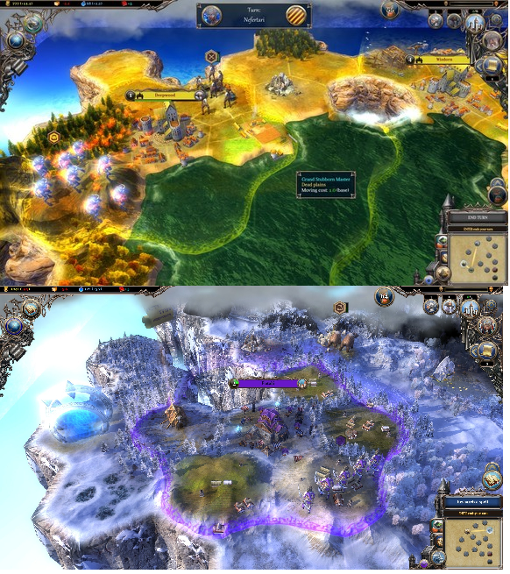

The overall look for the game will follow a color scheme and design similar to the one shown in the game Warlock 2: The Exiled, as shown to the right. This will aim to strike a balance between vibrant colors and a slightly mature aesthetic.

## Tutorial

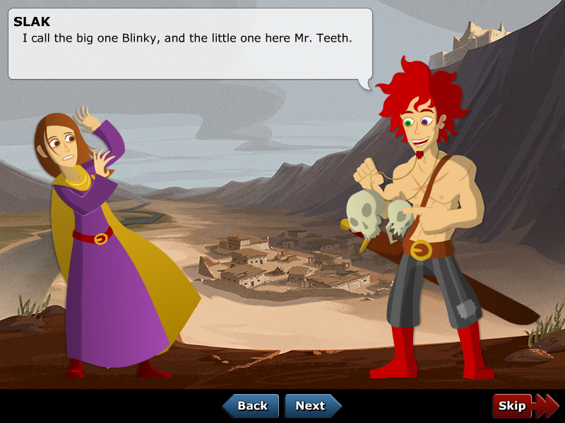

This section will involve two character sprites talking on the HUD, walking the player through the necessary game elements.

## HUD

The heads up display of the game will feature a border that persists in both town and Overworld modes, and frames the screen. Similar borders may be found in Starcraft 2, Warcraft 3, and Dota 2. It will contain permanent fixtures for the vital stats such as Gold, and buttons leading to other screens such as the pause menu & Econonomicron. Its purpose is mostly decorative and will have little mechanical impact.

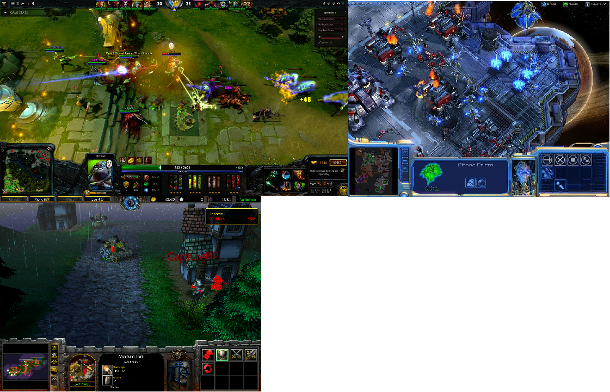

## Overworld Map

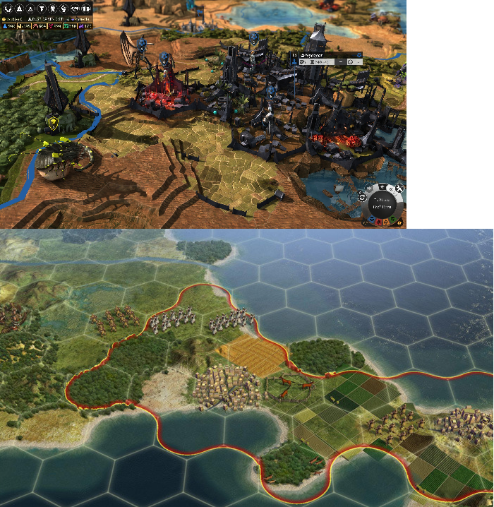

The Overworld will be viewed and navigated similar to strategy games such as Endless Legend and Civilizations 5. The predominant feature will be hex-based biomes and mouse-centric movement & interaction.

## Town Hub

The town hub will be observable from a birds-eye view, with points of interest highlighted to ensure the player can see them. The appearance will be similar to the Dungeons & Dragons Maps on the right, however they will be considerably more colorful.

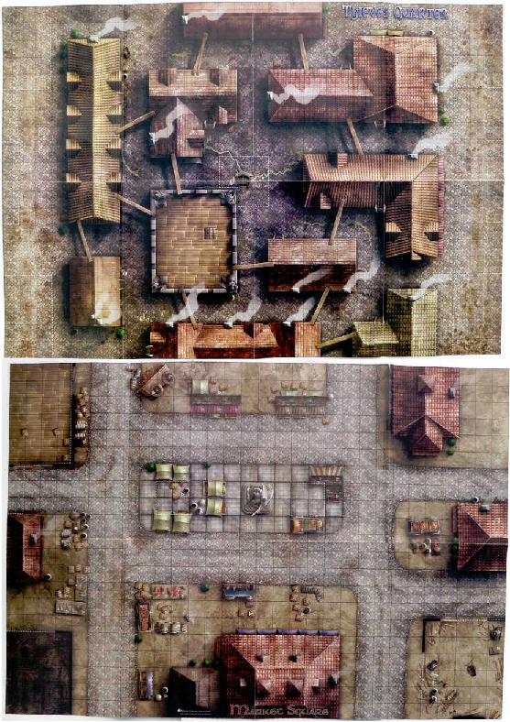

# Asset List

**Models:**

* Caravan Model
* Model of the Environment Hexes
  + Forest, Plains, Hills, Lake, Road, Town
  + Villager Model (Desirable)

**Textures:**

* Flat town Texture
* Texturing for Hexes
  + Forest, Plains, Hills, Lake, Road, Town
* Caravan Texture
* Main character sprites x 2
* Mountain Texture (Desirable)
* Desert Texture (Desirable)
* Ocean Texture (Desirable)
* Tooltip Portraits (Desirable)
  + Characters, Items, weapons

**Audio:**

* Overworld Music (loop)
* Town Music (loop)
* Battle Music (loop)
* Day/night Cycle prompt
* Selection sound (Desirable: section specific)
* Hover sound (Desirable: section specific)
* Desirable: NPC dialogue sound – Flavor text

**User Interface:**

* Selection window border (desirable)
* Custom Cursor (desirable)
* Custom Buttons
* Custom drop-down lists (desirable)
* Thematic Typeface font

# Testing & Analytics:

Primary concerns:

* Is the game able to teach Year 11 Accounting (Teach as well as assess)?
  + **Player feedback:** what is the player’s age & perceived mastery of the material at the start vs. after the game
  + **Playtest Observations:** do they show moments of understanding when learning & can they apply that to the game.
  + **Metric:** Amount of incorrect vs. correct answers for Quests AFTER they learn it.
  + **Analysis:** Improve learning experience based on feedback.
* Does the game inform players on the economic theory through gameplay
  + **Player Feedback:** Do they understand the macro and micro economics at work.
  + **Playtest Observations:** Are they making sense of the way the world operates.
  + **Metric:** # successful trades
  + **Analysis:** modify the economic system (mechanics, GUI, ect) in light of feedback.
* Are the mechanics seamlessly interwoven into the experience
  + **Player Feedback:** How do they find the mechanics, are they tedious?
  + **Playtest Observations:** does the player make negative utterances at any point (groans of frustration or irritation)
  + **Metric**: Time spent on certain tasks vs. others
  + **Analysis**: Modify mechanics to ensure they meld with the experience.
* Is the UI easy to navigate
  + **Player** **Feedback**: How did they find the user interface design.
  + **Playtest** **Observations**: Do they spend too much time figuring out the UI or did they miss something
  + **Metric**: Amount of time spent on particular windows, or clicking on something that doesn’t work
  + **Analysis**: Modify the UI based on the user feedback, to ensure it is intuitive
* How long does the game hold the player’s attention
  + **Player Feedback**: How long did they think they were playing for vs. the actual playtime
  + **Playtest** **Observations**: how long till the player stops playing
  + **Metric**: Total playtime in a session, without pausing
  + **Analysis**: Attempt to analyses what is causing the player to leave, and act on it.
* What is the perceived difficulty of the game
  + **Player Feedback:** How hard were the questions
  + **Playtest Observations:** Are they having difficulty answering the questions
  + **Metric:** number of times players have to use the HINT function.
  + **Analysis:** Change questions based on player feedback
* Correlation between age and skill playing the game
  + **Player Feedback:** what is the player’s age & perceived mastery of the material overall
  + **Playtest Observations:** confidence when starting vs. actually playing the game
  + **Metric:** in-game questionnaire
  + **Analysis:** tailor questions to be more toward the target audience
* How effective is the game’s tutorial
  + **Player Feedback:** How difficult is the tutorial as a learning mechanism
  + **Playtest observations**: does the tutorial not teach enough of the game
  + **Metric**: how long does it take to clear the tutorial & do they have to repeat sections
  + **Analysis**: modify the tutorial based on feedback.

# Technical Considerations:

## Hardware:

* Desktop/Laptop PC – Must be capable of meeting the minimum specs for each of the development software.
* Keyboard – Standard
* Mouse – Standard
* Headphones – Standard
* Audio Equipment – (TBA by Sound Engineer)

## Software:

* Unity 5.3.4f1 – Game Engine, Free version
* Adobe Suite – Texturing & normal mapping, Student Version
* Quixel – Texturing, Student Version
* 3ds Max – Modelling software, Student version
* Audio software – (TBA by Sound Engineer)
* Github Desktop – Version control software, free version
* Slack – Communication software, free version
* Trello – Project management & scheduling, free version
* Firefox – Web browser, free version.

# References:

Civilizations 5[Image]. (2011). Retrieved from http://assets.aspyr.com.s3.amazonaws.com/uploads/screenshot/image/169/CIV5_SS1.jpg

Defenders Quest [Image]. (2014). Retrieved from http://d2oah9q9xdinv5.cloudfront.net/cache/images/games/1/16/15769/crop_800x600/cutscene_1.png

Dota 2 [Image]. (2011). Retrieved from http://dota2.ingame.de/files/2011/08/dota21.jpg

Dungeons & Dragons [Image]. (2014). Retrieved from http://dmdavid.com/wp-content/uploads/2014/07/City_of_Peril11.jpg

Endless Legend [Image]. (2014). Retrieved from http://static1.gamespot.com/uploads/original/416/4161502/2687423-0001.jpg

Government of Western Australia, School Curriculum and Standards Authority. (2016). Accounting and Finance Course: Year 11 Syllabus [Syllabus]. Retrieved from http://wace1516.scsa.wa.edu.au/__data/assets/pdf_file/0018/9720/Accounting-and-Finance-Y11-Syllabus-General-2016-GD_pdf.pdf

Maivorsdotter, N., Quennerstedt, M., Öhman, M. (2015). Students’ Aesthetic Experiences of Playing Exergames: A Practical Epistemology Analysis of Learning [Journal Article]. Retrieved from http://oru.diva-portal.org/smash/get/diva2:802548/FULLTEXT01.pdf?frbrVersion=2

Morris, J. E., Lummis, G. W. & Lock G. (2014). Diagnostically Assessing Western Australian Year 11 Student’s Engagement with Theory in Visual Arts [Journal Article]. Retreived from http://www.aare.edu.au/data/2014_Conference/Full_papers/MORRIS_14.pdf

Niedenthal, S. (2009). What We Talk About When We Talk About Game Aesthetics [Journal Article]. Retrieved from http://www.digra.org/wp-content/uploads/digital-library/09287.17350.pdf

Skyrim [Image]. (2016). Retrieved from http://vignette4.wikia.nocookie.net/elderscrolls/images/c/c9/Riverwood_Trader_inside_Skyrim.jpg/revision/latest?cb=20120108010345.

Starcraft 2 [Image]. (2016). Retrieved from <http://vignette3.wikia.nocookie.net/starcraft/images/c/cb/Screenshot_SC2_DevGame1.jpg/revision/latest?cb=20080511221659>

RPGMart [Image]. (2013). Retrieved from http://i.imgur.com/siCjC4I.jpg

Warcraft 3 [Image]. (2013). Retrieved from http://media.moddb.com/images/mods/1/22/21742/Advance_Wars_CustomHUD_StormAndy.jpg

Warlock 2 [Image]. (2014). Retrieved from http://core0.staticworld.net/images/article/2014/05/warlock-2-fiataki-100268275-orig.jpg